Doctor brings stem cell therapy to North Dakota, only facility in state to offer the procedure

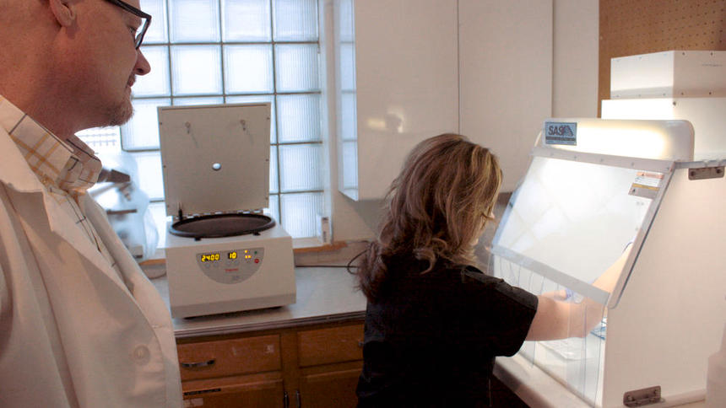
Dr. Forrest Lanchbury, a specialist in anti-aging and regenerative medicine and medical director at Bowman’s Southwest Healthcare Services, looks on as registered nurse Chrissy Blankenbaker works on a plasma-rich platelet procedure on Jan. 29 at the facility. Lanchbury and his team became the first to offer stem cell and PRP therapy in North Dakota in November. (Nadya Faulx / Forum News Service)

BOWMAN, N.D. -- Southwest North Dakota is a place known more for its oil industry than its health care, but one doctor is putting the region on the map with a new cutting-edge medical procedure that's attracting patients from across the state.
Dr. Forrest Lanchbury and a team of nurses now provide stem cell therapy to patients at Bowman's Southwest Healthcare Services, making it the only facility in North Dakota to offer the procedure, in which a patient's own stem cells are injected to a specific site in order to encourage healing.

Lanchbury, the facility's medical director, performed the first stem cell therapy in November, and has performed five total since the procedure became available.
"Everybody was really interested in it," he said, "and impressed with the potential to help patients."
Stem cell therapy is used to treat a multitude of ailments, from heart disease to neurological disorders, but Lanchbury said most of the patients who have undergone the procedure in Bowman do so to treat osteoarthritis and other joint diseases.
Stem cells multiply rapidly and can turn into other types of tissues and cells, depending on what needs to be healed, Lanchbury explained, meaning they have "the potential to heal any type of damaged tissue."
"Most healing takes place in any place in our body is done by stem cells," he said. "A cut, any injury to a tendon or ligament, or arthritis -- stem cells are involved within the body in healing that."
The process is deceptively simple: It involves harvesting an adult's own stem cells via liposuction (stem cells are also found in bone marrow, but are more plentiful in fat), mixing them with platelet-rich plasma and injecting the solution into the tendon or joint being treated.
The whole procedure, Lanchbury said, is minimally invasive, can be performed without anesthesia, and comes with a short recovery time and often quick results -- both stem cells and platelet-rich plasma have anti-inflammatory properties, so patients can see a reduction in pain within days and enjoy relief for years.
"It's a type of regenerative therapy, actually, a really powerful type of regenerative therapy," he said.
Lanchbury, who attended the Uniformed Services University of the Health Sciences in Bethesda, Md., and practiced medicine in Montana before arriving in Bowman, received his board certification in anti-aging and regenerative medicine before deciding to bring stem cell therapy to Bowman.
"It sparked my interest because, actually, a lot of stuff is going on in anti-aging, regenerative medicine with stem cells," he said.
Stem cell therapy therapy -- particularly when used to treat diseases like amyotrophic lateral sclerosis (ALS), Parkinson's and multiple sclerosis -- is more common in other countries than it is in the United States, he said, but it's becoming more common stateside in the treatment of muscular and skeletal diseases.
Before, treatment for ailments like arthritis was limited to surgery, steroids, walkers or surgery to repair or even replace joints. Stem cell therapy offers osteoarthritis patients a way to avoid joint surgery, or at least put surgery off for a while. The two treatments are often used in conjunction. Among other benefits is the cost: Surgery can run as much as $30,000 to $40,000, while stem cell therapy can cost around $7,000 for one procedure.
Lanchbury said word of the new treatment spread quickly among patients after the Southwest Healthcare Services board gave Lanchbury the go-ahead to begin offering the procedure and his team -- registered nurses Chrissy Blankenbaker and Wanda Henderson, and certified nursing assistant Tasha Heinrich -- trained with a representative from the Florida-based Ageless Aesthetic Institute.
Lanchbury said he isn't sure why the therapy isn't more common among doctors, or why he was the first in North Dakota to introduce the procedure, just that he is "the one who took initiative to do it. Others could do it if they wanted."
"The therapy itself has been used a lot with great results," he said. "It doesn't take really any special place to do it. It doesn't take a lot of equipment. It requires some of the same skills that doctors already have."
He admits he was "a little bit nervous" in bringing stem cell therapy to Bowman, but he went ahead "because I knew it was something important, something I could help patients with.
"Patients were aware of (stem cell therapy), but not really aware of how it could be incorporated here," Lanchbury said. "Once I got done with my training, I was able to present that to them, that this is what I want to do."
He said that so far the new offering -- as well as platelet-rich plasma therapy -- has attracted patients from across North Dakota and neighboring states who might otherwise have to travel as far as the Mayo Clinic in Rochester, Minn., to receive the same treatment.
Blankenbaker, who has worked at the Bowman facility for nearly a decade, said she had never imagined getting to work on something like stem cell therapy, but it was "an opportunity that presented itself," saying it has been rewarding to be able to help patients.
"In the cases we've done, we've seen such excellent results," she said. "It's definitely rewarding that we get to have such a great impact."
The procedure isn't for all patients, however. Stem cell therapy may not be effective against severe arthritis, for example. Lanchbury meets with each of his prospective patients to determine whether or not they qualify: those with underlying diseases, including cancer or bleeding problems, are not able to receive the therapy.
And while stem cell therapy is less expensive on the outset than joint replacement or other surgery, in most cases, the procedure isn't covered by insurance. Most insurance providers consider stem cell therapy to be "experimental," Lanchbury said, so patients have to pay for it out-of-pocket.
Still, despite the challenges, both Blankenbaker and Lanchbury said they hope and expect stem cell therapy to only expand in Bowman and beyond, both in the types of diseases and the number of patients it can be used to treat.
"We just hope that we can help as many patients as we can doing this," Blankenbaker said. "As many as we can possibly assist."

